Final project proposal

Mechatronics

Anqi Li 2019-spring

**Step 1: Electrics Parts Preparation**

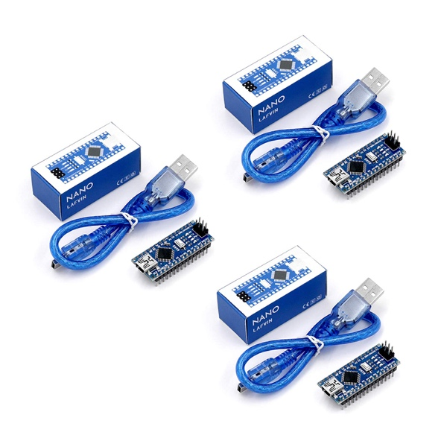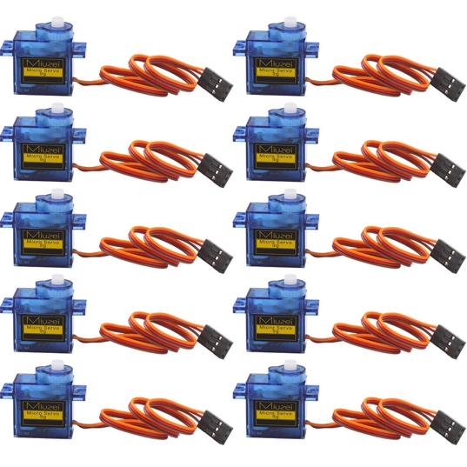

1x Arduino Nano

12x SG90 servo (12-5v/ 3A)

1x 4cm*6cm perfboard

Some male and female pin headers

**Step 2: Make the Main-board**

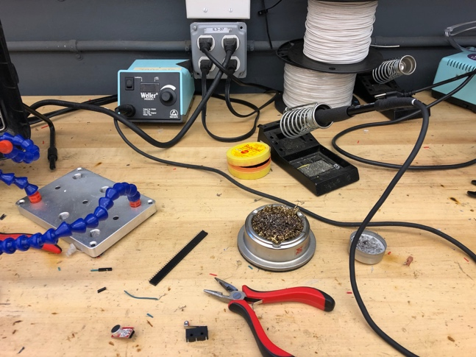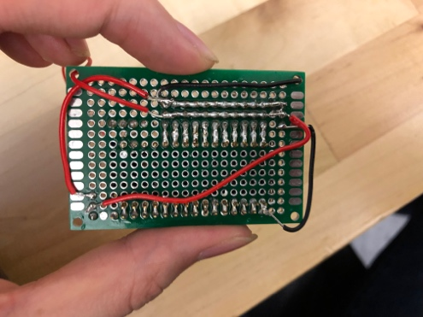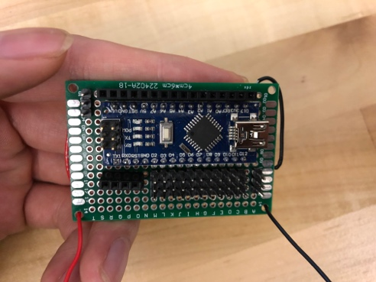

Connect male pins to the Arduino Nano on the perfbord.

Then connect these male pins’ second and third pins together which will be “+” and “-” for servos. There are 11 pins on one side on the Arduino Nano, you have to add one more servo pins on the other side.

**Step 3: Building the Mechanical Parts**

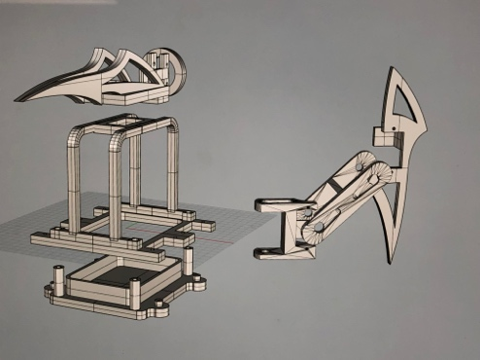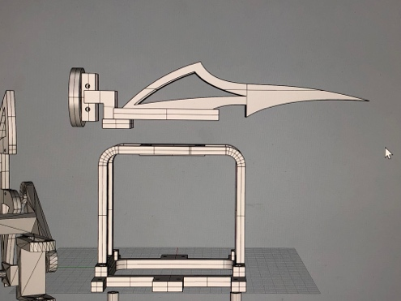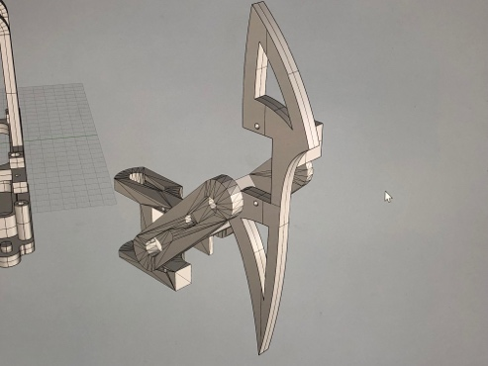

This step is going to build the spider mechanical parts, you need to use a 3D printer to print out all the parts.

I used the first two parts of the legs from the internet and I designed the third part which has sharp angle and super cool. Also, I have a top arrow part for attacking.

**Step 4: 3D Printing**

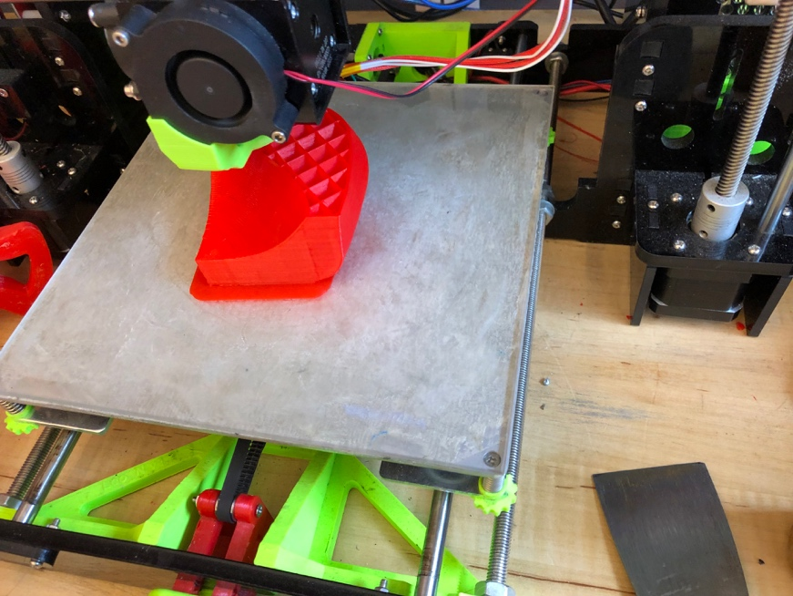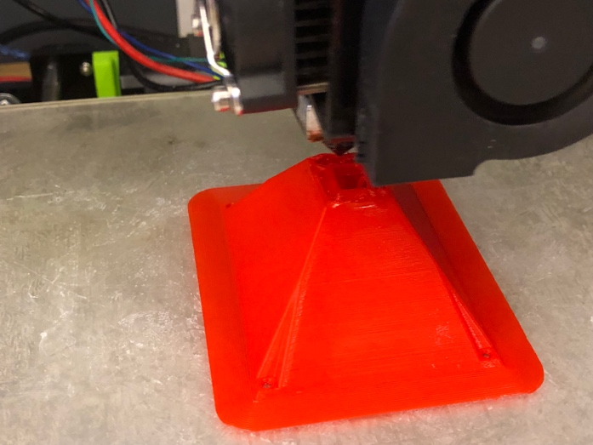

Print objects from the 3D files and clean the supports carefully.

**Step 5: Spider Assemable**

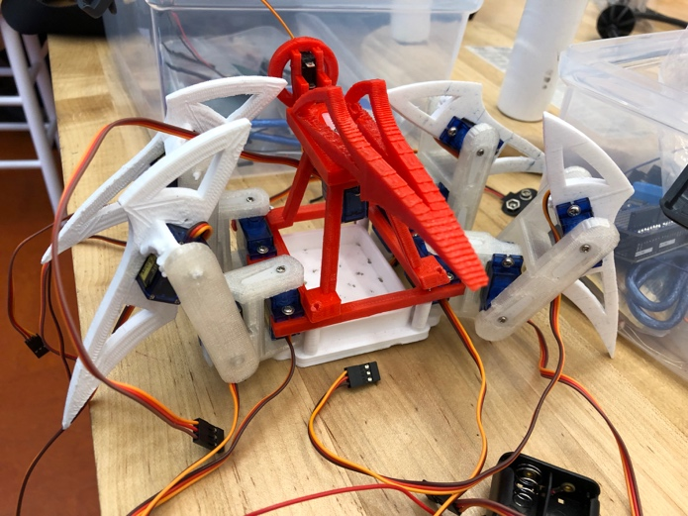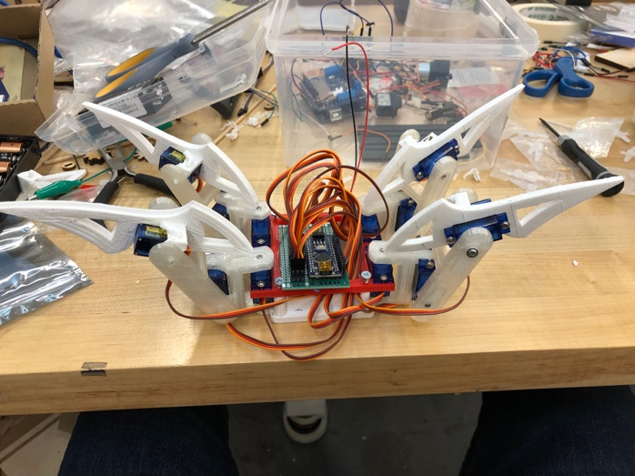

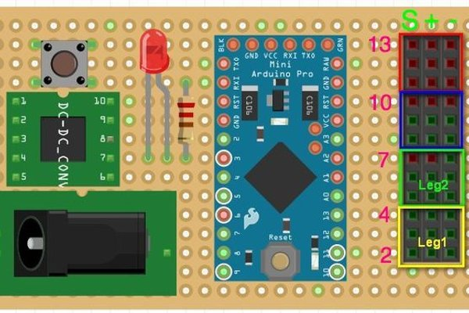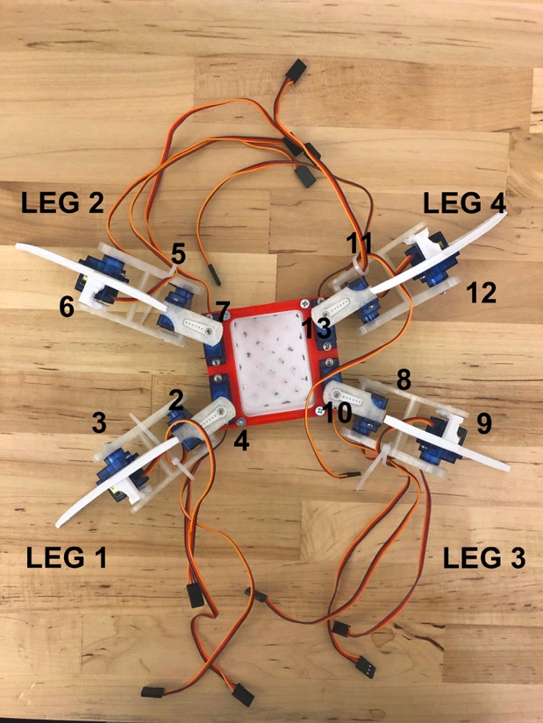

Connect all parts with servos but don’t tighten the screw, since that we need to initial the legs later.

Than connect the servos to the main-board. It looks super cool now!

**Step 6: Locate the Initial Position for 4 legs**

1: upload the “1-code” to Arduino to activate all servos

2: adjust the legs to make sure the first two parts are strait and the third part is perpendicular to the ground

3: tighten all of the screws

**Step 7: Spider move**

Upload the “2-code” to Arduino to make it alive!

